Lincoln Northeast High School
2635 N 63rd Street • Lincoln, NE 68507 • (402) 436-1303 • Fax (402) 436-1345
http://lne.lps.org

13451345 • http://lne.lps.org

2020 - 2021
LNE Rocket Messenger
September

Hello Rocket Family,

I hope this finds you well! What an opportunity we’ve had to learn and grow together since Quarter 4. By now our Scholars and Teachers have, for the most part, settled into our temporary new norm. I want to let you know how incredibly impressed I have been with our Scholars and the way in which they are adjusting to our 50% capacity learning plan. This also especially includes wearing their Face Coverings. We so appreciate your support and partnership. Thank you!

Our Teachers have been working sooo hard to provide the best learning environment possible. I know there have been some hiccups along the way but I am so impressed with the way in which Scholars and Teachers have persevered!

School Improvement Focus:

Our areas of focus for the 2020-2021 school year will again be: Effective Instruction, Culture for Learning and Equity.

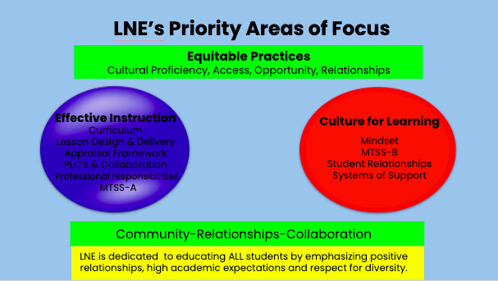
News and Notes:

-Textbooks/Materials: Please encourage your Student to double check to ensure they still don’t have any school materials/textbooks at home from last year. We are short books for some of our classes, such as AP Psychology and History, so any materials that can be returned would be greatly appreciated.

-Attendance: As a point of clarification, should your student be absent on the day they are to physically be in school, please do not have them contact teachers asking to be let into Zoom. If they gone, then they are not to be zooming in. Participation IS expected from students even on their Zoom days!

-Technical Difficulties: Should your student have technical difficulties when trying to join a class, they should first restart their Chromebooks. Second, please have them email their teacher during the period. After the class period, they should call the attendance office. Should your student need a hot spot to assist with internet, they should call 402-436-1735.

-Turf Installation: The Board of Education recently approved the turf installation project at LNE and LSE. Installation preparation has begun. I just wanted you to be aware of this project as we begin to see large trucks on campus. We’re told the project may take a large portion of this first semester.

Important Dates
Sept. 17 Homecoming Football Game
7:00 p.m. Limited Attendance
Sept. 22 ACT test - Seniors Only in Attendance
8:00 a.m.
Oct. 6 Financial Aid presentation
6:30 p.m.
Oct. 7 NHS Induction Ceremony
7:00 p.m.
Oct. 16 Fall Break (3-day weekend)

More activities’ information can be found on the LNE web calendar at https://lne.lps.org/calendar/ or on the LNE athletic calendar at https://www.heartlandathleticconference.org/public/genie/406/school/6/date/2020-01-27/view/week/

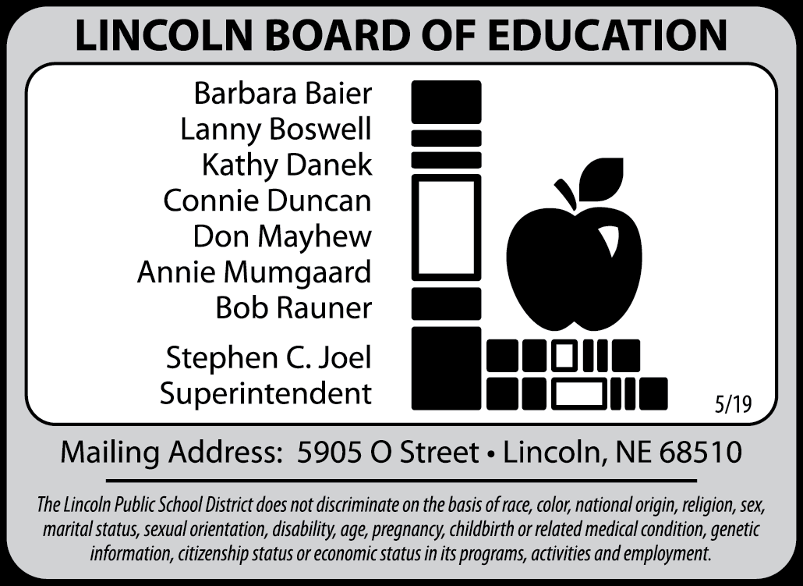

Community Learning Center (CLC)

Welcome back to Northeast! We are excited to see everyone in the Community Learning Center (CLC) space this year. Any student wishing to use the media center after school or be involved in any Community Learning Center (CLC) activities this year will require a parent/guardian fill out a waiver. The waiver can be found by going to lps.org and using the jump code: R8YG or can be found directly at https://docs.google.com/forms/d/e/1FAIpQLSd0wlhklFy51D3kBFYzdo4y8iPlMkN49MP1hfWqy0otvGwv1w/viewform

We are excited to share all the new opportunities we have planned with you for this upcoming school year. If you have any questions about the Lincoln Northeast Community Learning Center, you can contact the site director, Michael Bandy, at michael.bandy@civicnebraska.org.

FIRST Semester Testing Information:

ACT: The ACT for last year’s juniors will be given on Sept 22, 2020. Students taking the test will be the only students in the building on this day. Students not taking the ACT will not have school on Sept 22, 2020.

The ACT on Sept 22 will not include the writing portion of the exam. Students will take the English, Math, Reading and Science test only.

Testing begins at 8:00 a.m. Students are asked to bring a photo ID (student ID), #2 pencil and a calculator. Please do NOT bring electronic devices (cell phone, iPod, smartwatch, etc.). Food, drinks, and electronic devices are not allowed in the classrooms.

Before taking the ACT test, students must complete the Pre-test Inventory of the exam at LNE. The required portions include Name, Address, Birthday, Student ID, and may list up to 4 colleges they would like the scores sent to. Optional parts include High School Course/Grade Information, Student Profile Section, and ACT Interest Inventory. Students who attend in-person will be asked to fill out their ACT Pre-Test Inventory during the school day. Students who are 100% remote learners are asked to come after school on Sept 11 at 1:50 pm to complete the ACT Pre-Test Inventory. If this date will not work, there will be a make-up session for 100% remote students on Sept 16 at 2:30 pm.

ACT Preparation: ACT has provided a number of resources to help prepare to take the ACT test, including the opportunity to take a practice test in an online format.

On Student Chromebooks: Before students log into their Chromebooks, click on the APPs button on the bottom left hand corner and choose the TestNav app. Then click on “The ACT” on the top left. The next screen is the login screen, look under the “Sign In” button and click on “Practice Tests”. Finally choose the test you wish to practice.

Paper Version of a Practice Test: Students also have access to a paper version of the practice test available in the counseling center or main office. This practice version is also available as a PDF on the following website: https://www.act.org/content/act/en/products-and-services/state-and-district-solutions/act-info-for-examinees.html

Information from the LNE Counseling Center

Senior Class of 2021 - It’s time to prepare!

ACT Testing
Seniors will have the opportunity to take the ACT at Lincoln Northeast on September 22nd at no cost. For those wanting to take it again, the following National Test Dates are available:

October 10 & October 24 (Registration Deadline September 25)
December 12 (Registration Deadline November 6)
ACT Registration instructions are posted on the LNE Website. Go to www.actstudent.org to register. Fee waivers are available for students who have financial need; see your LNE Counselor. Test preparation booklets are available in the Counseling Center and the main office. LPS also offers ACT Prep classes. Go to http://wp.lps.org/testprep for more information, or see your friendly LNE counselor.

SAT Test is Saturday, October 3 (late registration is September 15 for mailed registrations and September 22 for registrations made online or by phone).

Attend the EducationQuest Virtual College Fair Sept. 27 – 30
The Virtual College Fair featuring college reps from across the state, region, and nation will be available to answer your questions about their schools – all from your computer or device!

Here’s how it works:
Step 1: Register for the virtual college fair.
Step 2: Watch live college-prep presentations.
Experts will be live on September 27 to explore topics such as:
- College admission
- Selecting a major
- Campus visits
- Scholarship tips
- Paying for college
Space is limited, but sessions will be recorded for later viewing.
Step 3: Visit college booths.
Use the filter option to find schools that match your criteria. The booths will feature videos, live chats, and information about the school. Come prepared with questions to ask the reps.
Reps will be available during these times, but you can visit the booths anytime.
- Sunday, September 27 – 2:00 p.m. – 8:00 p.m. CT
- Monday, September 28 – 8:00 a.m. – 2:00 p.m. CT
- Tuesday, September 29 – 1:00 p.m. – 8:00 p.m. CT
- Wednesday, September 30 – 1:00 p.m. – 8:00 p.m. CT

FAFSA - It is time to prepare early!
Beginning October 1, seniors can apply for federal, state and college-based financial aid by completing the Free Application for Federal Student Aid (FAFSA). Go to EducationQuest.org for more information about financial aid, the FAFSA, and scholarships. This is an essential step for college access and planning for education beyond high school.

LNE Financial Aid Night - Financial Aid Presentations show families how to pay for college. Lincoln Northeast will provide a Financial Aid presentation on October 6, 2020 at 6:30 p.m. EducationQuest staff will share financial aid and FAFSA information with students and parents.

EducationQuest will also host statewide Financial Aid Programs during September to reach families who can't attend their school's event. Register to attend one of these virtual events:

September 21 - English & Spanish

September 22 - English & Spanish

September 23 - English & Spanish

September 24 - English & Spanish

High School juniors and seniors who attend a Financial Aid Program will be eligible to register for one of six $500 scholarships.

Juniors - PSAT Test
The PSAT will be given at Lincoln Northeast on Saturday, October 17, 2020, 8:00 to 11:30 a.m.
Plan ahead: This test will take place over the LPS Fall Break.
JUNIORS - The PSAT is the qualifying test for the National Merit Scholarship Competition.
SOPHOMORES - Can take the PSAT as a practice and to prepare for taking the test their junior year. Test registration will begin in late September - watch for announcements.

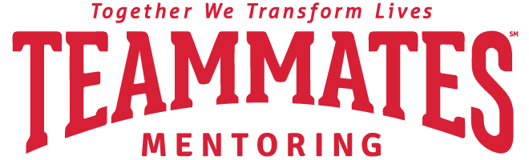

TEAMMATES Mentors Needed
Would you be willing to invest in one child’s life? Become a mentor with the TEAMMATES Mentoring Program at LNE. Meet with a student (grades 9-12) at school during school hours once a week for 30-60 minutes. Build a caring relationship while playing games and sharing interests. Focus on the student’s strengths and foster their hopes and vision for their future.

Take the next step. All it takes is an application, which can be filled out online (say that you saw this in the LNE newsletter) at lincolnteammates.org; a background check and a training session are required. For more information, contact Mrs. Kristin Skorupa at kskorup@lps.org or 436-1303, option 2.

Updates from the LNE Media Center

Undoubtedly, your student is Zooming in for some, maybe all, of his/her classes. A good tip to know when you’re at home is how to use the Northeast libraries HOME ACCESS links and passwords available to all Lincoln Northeast students when not at school. This tip will make the frustration of using the library website a little bit easier when schooling from home.

Many of our databases are paid subscriptions and we promise to keep the passwords behind a document that can be accessed when students enter their username (student ID) and password.

From the Library Website (https://home.lps.org/lnelibrary/) you’ll see an image which takes you to the HOME ACCESS links and passwords. If your student still needs help, please remind them to stop by the library. We’re always glad to help.

These links may help your student find a good book or assist with research in an Oral Comm. or other classes. Take a look at two new eBOOKS for this school year -

COMICS PLUS and TEEN BOOK CLOUD. Check them out!
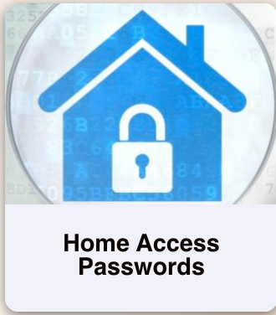

School Picture Retakes

School picture retakes will take place in October on an A day and a B day, dates to be determined. If you did not order school pictures in August or if your picture that was taken in August is not satisfactory, this is your last opportunity for school pictures this year. If you will be requesting a retake, bring the first package back to the photographer at the time the new picture is taken, there isn't a charge for retakes if the original package is returned. Pre-paid picture packages are now available in the main office to be picked up by parents or students. Students can also pick them up during lunch in the commons the week of September 14 – 18.

If you would like to order pictures for your student(s) who had pictures taken during Rocket Ready Days or on the first day of school, you can order online at mylifetouch.com using Picture Day ID: EVTGXGZVT.
Pictures taken in October will not be used for school IDs.

Once a Rocket, Always a Rocket!

